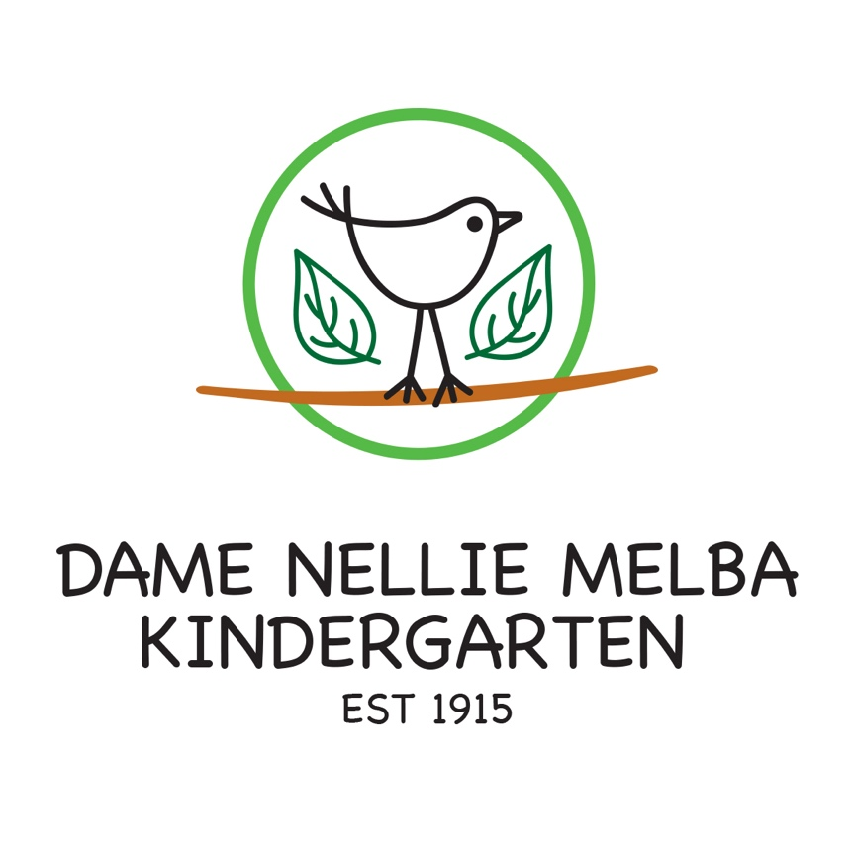
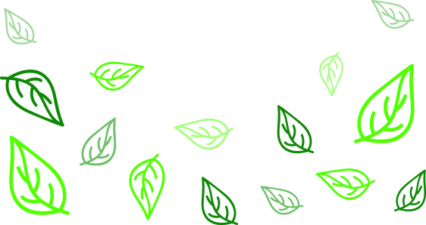
Social Media Policy
Best Practice– Quality Area 2

PURPOSE
This policy will outline guidelines for and responsibilities when using social media.

POLICY STATEMENT

1. VALUES
DNMK is committed to:
- considering the wellbeing of each child at the service as paramount
- maintaining a duty of care (refer to Definitions) towards all children at the service
- providing a safe and secure environment for all at the service
- respecting the rights of the child
- providing an open, welcoming environment in which everyone’s contribution is valued and respected
- encouraging parents/guardians, volunteers, students and community members to support and participate in the program and activities of the service.

2. SCOPE
This policy applies to the Approved Provider, Nominated Supervisor, Person in day to day charge, educators, staff, students on placement, volunteers, parents/guardians and all adults participating in the programs and activities of DNMK

3. BACKGROUND AND LEGISLATION
Background By joining the DNMK team/community you occupy a position of trust and responsibility. As a DNMK employee you have agreed to comply with:
- the DNMK Philosophy
- the Code of Conduct Policy
- The Privacy and Confidentiality Policy and
- all relevant DNMK policies that apply to you, including this Social Media Policy
In relation to your use of social media, you may have obligations to the service that arise:
- outside of working hours, or
- when you are acting in an official and unofficial capacity, and
- even when posting material anonymously, or using an ‘alias’ or pseudonym
This policy was developed so you feel empowered to participate online, while being mindful of your responsibilities and obligations under DNMK’s policies.
Social media consists of websites and applications that allow users to create and share content and to participate in social networking. Social media may include, but is not limited to:
- social networking sites, including Facebook, LinkedIn or Google+
- video and photo sharing websites, for example Snapchat, Flickr, Instagram, YouTube and Pinterest
- media sites hosting articles with comments, for example newshub
- micro-blogging sites, for example Twitter and Tumblr
- forums and discussion groups, such as speechbubble, Google groups or Whirlpool
- wikis, for example Wikipedia
- podcasting sites, for example SoundCloud
- online gaming platforms, for example World of Warcraft or Second Life
- geo-spatial tagging, such as Foursquare and Facebook check-in
As you can see from these examples, social media is diverse. It has become a part of how we live our lives today, and is a valuable tool for many people.

Currently DNMK has no social media presence. We do have plans in the near future to utilize Instagram for advertising kinder events and updates. This Policy will be

Legislation and standards
Relevant legislation and standards include but are not limited to:
- Charter of Human Rights and Responsibilities Act 2006 (Vic)
- Information Privacy Act 2000
- National Quality Standard, Quality Area 4: Staffing Arrangements
- Occupational Health and Safety Act 2004
- Occupational Health and Safety Regulations 2007
- Racial Discrimination Act 1975
- Racial and Religious Tolerance Act 2001 (Vic)
- Sex Discrimination Act 1984 (Cth)

4. DEFINITIONS
The terms defined in this section relate specifically to this policy. For commonly used terms e.g. Approved Provider, Nominated Supervisor, Regulatory Authority etc. refer to the General Definitions section of this manual.
Duty of care: A common law concept that refers to the responsibilities of organisations to provide people with an adequate level of protection against harm and all reasonable foreseeable risk of injury
Harassment: When someone is demeaning, derogatory or intimidating towards another person. Harassment includes:
- racial taunts
- taunts about sexual orientation or gender identity
- sexual harassment: unwelcome physical, verbal or written behaviour of a sexual nature
- repeated insulting remarks.

Posting: Contributing a piece of content to a social media channel. This can either be original content or in reply to original content
Profile: Also called a bio is the description of a user’s identity on a social media channel and could include information such as the person’s characteristics and what the channel is used for
Respect: Value the rights, religious beliefs and practices of individuals. Refrain from actions and behaviour that constitute harassment or discrimination.
Social Media: The term social media is an umbrella term used to describe a suite of tools on the web, which typically have the following characteristics:
- mostly free to use
- extremely simple to use requiring no prior training or technical knowledge
- support global collaboration and sharing of opinions, insights, experiences and perspectives often with strangers
- content within them and often the functionality, is managed and regulated by the user community itself and not the provider of the tool or a third party institution.
A non-exhaustive list of examples of social media tools are: blogs, wikis and social networking sites, for example Facebook, Twitter, LinkedIn, YouTube, Google+, Flickr, Instagram, Pinterest
Support: Work in a co-operative and positive manner.

5. SOURCES AND RELATED POLICIES

Sources
- Adapted from The University of Melbourne, Social Media Guidelines (2016) (https://socialmedia.unimelb.edu.au/resources/social-media-guidelines)

Service policies
- Code of Conduct Policy
- Privacy and Confidentiality Policy

PROCEDURES

Personal use of social media
We support employees who choose to use social media in their capacity as private citizens, without intrusion. While acting as private citizens, please be mindful that your online behaviour must be lawful, and you may still be bound by the DNMK Code of Conduct, Privacy and Confidentiality Policy, and also other policies. Below, this policy outlines a number of your key obligations in relation to your personal use of social media.
When using social media, you must:
- uphold DNMK Code of Conduct, Privacy and Confidentiality Policy, and also other policies which includes, at all times, behaving in a way that is in line with the philosophy and values of DNMK.
- be aware your posts not only reflect on you, but can reflect on the kinder, particularly if you identify as DNMK staff.
- remember that where you are identified, or could reasonably be identified as an employee of DNMK, be polite and respectful of the opinions of others at all times, and not disparage the service’s employees, families, children and other members of the DNMK Community.
- be conscious that social media is a public forum that provides little opportunity for people to defend themselves against personal attacks and therefore, criticisms can be highly prejudicial
- not use social media to publicly complain about your employment, as the appropriate process for resolving such complaints are through discussions with your manager, or via the service’s internal dispute or complaints resolution processes.
When using social media, it is not acceptable at any time to:
- post comments or images that are obscene, defamatory, threatening, harassing or discriminatory in relation to your work, a staff member, children, families and other members of the DNMK Community.
- use a work email address to register personal social media accounts
- post any photos which contain images of children associated with the service including photos where faces cannot be seen
- disclose confidential customer information
- post inappropriate images on social media that reference the kindergarten in some way — for example, photos taken of employees engaging in misconduct at a social event.
Before deciding to post something in a private capacity, you also need to be mindful that:
- your anonymity online is far from guaranteed, anyone who posts material online should make an assumption that at some point their identity and the nature of their employment will be revealed
- material posted online effectively lasts forever and may be replicated endlessly, through sharing and re-posting
- material posted online may also be sent to recipients who you never expected to see it, or who may view it out of context
- the speed and reach of content posted on social media means that comments posted online are available immediately to a wide audience
- a site's security settings are not a guarantee of privacy which means material posted in a relatively secure setting can still be copied and reproduced elsewhere

If you’re not sure, get some more information
The terms and prescribed conduct described in this policy are not intended to be exhaustive, nor do they anticipate every possible use of social media. You are encouraged to act with caution and to take into account the underlying principles of this policy.
You should contact the Approved Provider or Nominated Supervisor if:
- you are not sure if you should get involved in social media commentary or participate in an online discussion
- you are worried about your privacy or reputation as a result of social media posts
- you find information online you think the Committee needs to know about, this includes inappropriate activity on social media by staff

Breaches of the social media policy
This policy sets out the rules which must be complied with when using social media. This policy is a direction to you by the Committee as an employee at DNMK. You must comply with this policy.
In situations where a staff member’s online behaviour potentially breaches the DNMK Code of Conduct, Privacy and Confidentiality Policy or Social Media Policy the issue will be referred to the Committee for investigation and action.
If you are found to have breached the Committee may determine that it is appropriate to impose a sanction, which could include:
- termination of employment
- reduction in hours
- reassignment of duties
- reprimand or written warning

EVALUATION
In order to assess whether the values and purposes of the policy have been achieved, the Approved Provider will:
- regularly seek feedback from everyone affected by the policy regarding its effectiveness
- monitor the implementation, compliance, complaints and incidents in relation to this policy and ensure satisfactory resolutions have been achieved
- keep the policy up to date with current legislation, research, policy and best practice
- revise the policy and procedures as part of the service’s policy review cycle, or as required
- notify parents/guardians at least 14 days before making any changes to this policy or its procedures.

ATTACHMENTS
Attachment 1: Guidelines for Social Media Use
AUTHORISATION

This policy was adopted by the Approved Provider of Dame Nellie Melba Kindergarten on August 2019

REVIEW DATE: August 2020

APPENDIX 1 Guidelines for Social Media use

Adapted from The University of Melbourne, Social Media Guidelines (2016) (https://socialmedia.unimelb.edu.au/resources/social-media-guidelines)
Maintain confidentiality – only post publicly available information. Don't disclose or discuss confidential information, make commitments or engage in activities on behalf of DNMK unless you are authorised to do so.
Protect and respect privacy – check the account privacy settings are appropriate for the scope of engagement you wish to undertake. Always protect your own privacy and personal information, and don't share the private details of others. Don't disclose details of private conversations unless you have obtained explicit consent from the relevant parties.
Be impartial – avoid statements that advocate or criticise policies of DNMK, external organisations, government or political parties. Avoid conflicts of interest through endorsement or criticism of third-party providers, partners, products or services.
Be respectful – be courteous and polite, and sensitive to diversity. Avoid arguments and don't make personal attacks. Do not post obscene, defamatory, threatening, harassing, discriminatory or hateful content.
Be accurate – make sure the information you publish is correct and cite sources where appropriate – people may make decisions based on information you post.
Consider intellectual property – respect copyright. Always get permission to use words, images or materials online that you do not own.
Accountability – always take responsibility for your actions. If you make a mistake, admit it, and where possible make public corrections.
Think first – review your content before you post it. Remember that you are responsible for your actions. You should consider the impact your activities could have on yourself and/or DNMK. Use your common sense and best judgement. If you're not sure, check with the Nominated Supervisor. If in doubt, leave it out.

