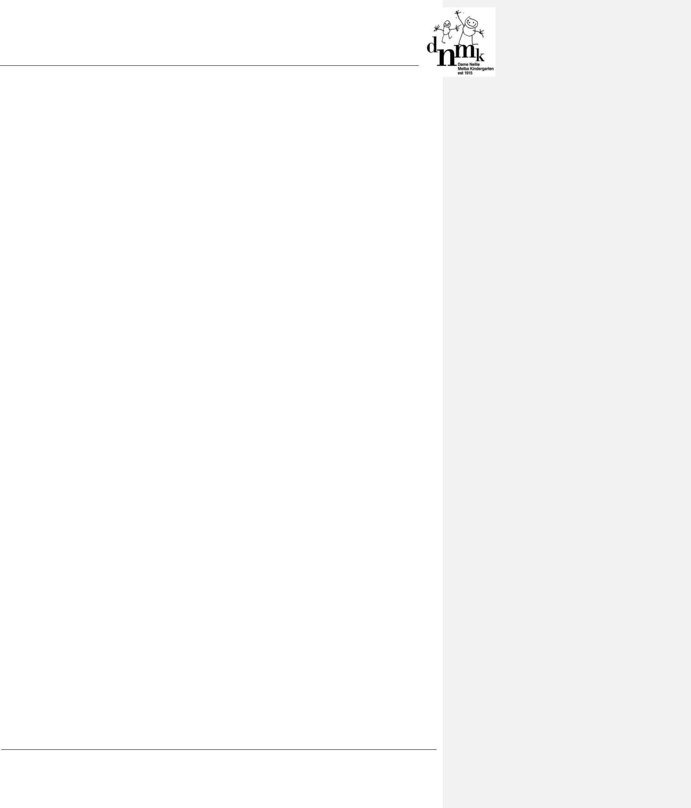

CODE OF CONDUCT POLICY

Mandatory – Quality Area 4

PURPOSE

This policy provides guidelines to enable DNMK to:

- establish the expected standards of behaviour for the Approved Provider, Nominated Supervisor, staff, contractors, volunteers, students on placement, parents/guardians and visitors

- create and maintain a child safe environment that reflects the philosophy, beliefs, objectives and values of DNMK

- promote desirable and appropriate behaviour

- promote interactions at the service which are respectful, honest, courteous, sensitive, tactful and considerate.

POLICY STATEMENT

- VALUES

DNMK:

• respects the rights of the child and values diversity

- acknowledges the vulnerability of Aboriginal children, children from a culturally and linguistically diverse background and children with a disability and has zero tolerance of discrimination

- maintains a duty of care (refer to Definitions) towards all children at the service

- is committed to the safety and wellbeing of each child at the service

- is committed to the safety and wellbeing of all staff at the service

- provides a safe and secure environment for all at the service

- provides an open, welcoming environment in which everyone’s contribution is valued and respected

- is committed to communicating openly and honestly

- is committed to continually learning how to be inclusive and respectful of cultural needs

- encourages volunteers, students, parents/guardians and visitors to support and participate in the program and activities of the service.

2. SCOPE

This policy applies to the Approved Provider, Nominated Supervisor, staff, contractors, volunteers, students on placement, parents/guardians and visitors attending the programs and activities of DNMK.

3. BACKGROUND AND LEGISLATION

Background

Codes of conduct establish standards of behaviour to be followed and define how individuals are expected to behave towards each other, towards the children in their care, and towards other organisations and individuals in the community.

The Approved Provider, Nominated Supervisor and staff have a duty of care to the children attending the service and must ensure ‘that every reasonable precaution is taken to protect children being educated and cared for by the service from harm and from any hazard likely to cause injury’ (National Law: Section 167).

The National Quality Standard requires that staff are respectful and ethical and that ‘professional standards guide practice, interactions and relationships’ (National Quality Standard: 4.2 and 4.2.1).

DNMK Policies & Procedures Code of Conduct Policy – July, 2017

Page 1 of 14
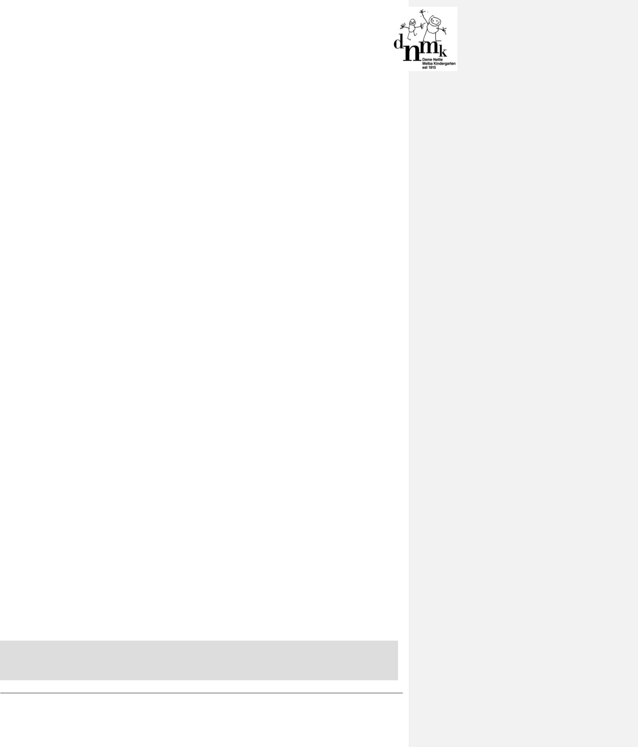

Employers also have a legal responsibility to provide, as far as is practicable, a safe workplace that is free from discrimination, bullying and harassment.

Child Safe Standard 3 requires services to develop and review codes of conduct that establish clear expectations for appropriate behaviour with children including:

- how to respond to risks adults may pose to children or that children may pose to each other

- how to ensure the cultural safety of Aboriginal children and culturally and linguistically diverse children

- how to be inclusive of all children, including children with a disability.

A Code of Conduct should be informed by the service’s philosophy, beliefs and values, and based on ethical principles of mutual respect, equity and fairness. Consideration should be given to the Victorian Teaching Profession Code of Conduct and the Code of Ethics and to the Early Childhood Australia’s Code of Ethics in developing the code of conduct.

The Approved Provider must ensure that the Nominated Supervisor, staff, contractors, volunteers, students on placement, parents/guardians, children and others attending the programs and activities of DNMK adhere to the expectations outlined in the Code of Conduct when communicating to and interacting with:

- children at the service and their parents and family members

- each other

- others in the community.

Legislation and standards

Relevant legislation and standards include but are not limited to:

- Charter of Human Rights and Responsibilities Act 2006 (Vic)

- Child Safe Standards (Vic)

- Children, Youth and Families Act 2005 (Vic)

- Child Wellbeing and Safety Act 2005 (Vic)

- Disability Discrimination Act 1992 (Cth)

- Education and Care Services National Law Act 2010: Sections 166, 167, 174

- Education and Care Services National Regulations 2011: Regulations 155, 156, 157, 175

- Equal Opportunity Act 2010 (Vic)

- Fair Work Act 2009 (Cth)

- Fair Work Regulations 2009 (Cth)

- National Quality Standard, Quality Area 4: Staffing Arrangements

− Standard 4.2: Educators, coordinators and staff members are respectful and ethical

− Element 4.2.1: Professional standards guide practice, interactions and relationships

- Occupational Health and Safety Act 2004

- Occupational Health and Safety Regulations 2007

- Racial Discrimination Act 1975

- Racial and Religious Tolerance Act 2001 (Vic)

- Sex Discrimination Act 1984 (Cth)

- Victorian Institute of Teaching The Victorian Teaching Profession Code of Conduct

- Victorian Institute of Teaching The Victorian Teaching Profession Code of Ethics

The most current amendments to listed legislation can be found at:

- Victorian Legislation – Victorian Law Today: http://www.legislation.vic.gov.au

- Commonwealth Legislation – Federal Register of Legislation: https://www.legislation.gov.au/

DNMK Policies & Procedures Code of Conduct Policy – July, 2017

Page 2 of 14
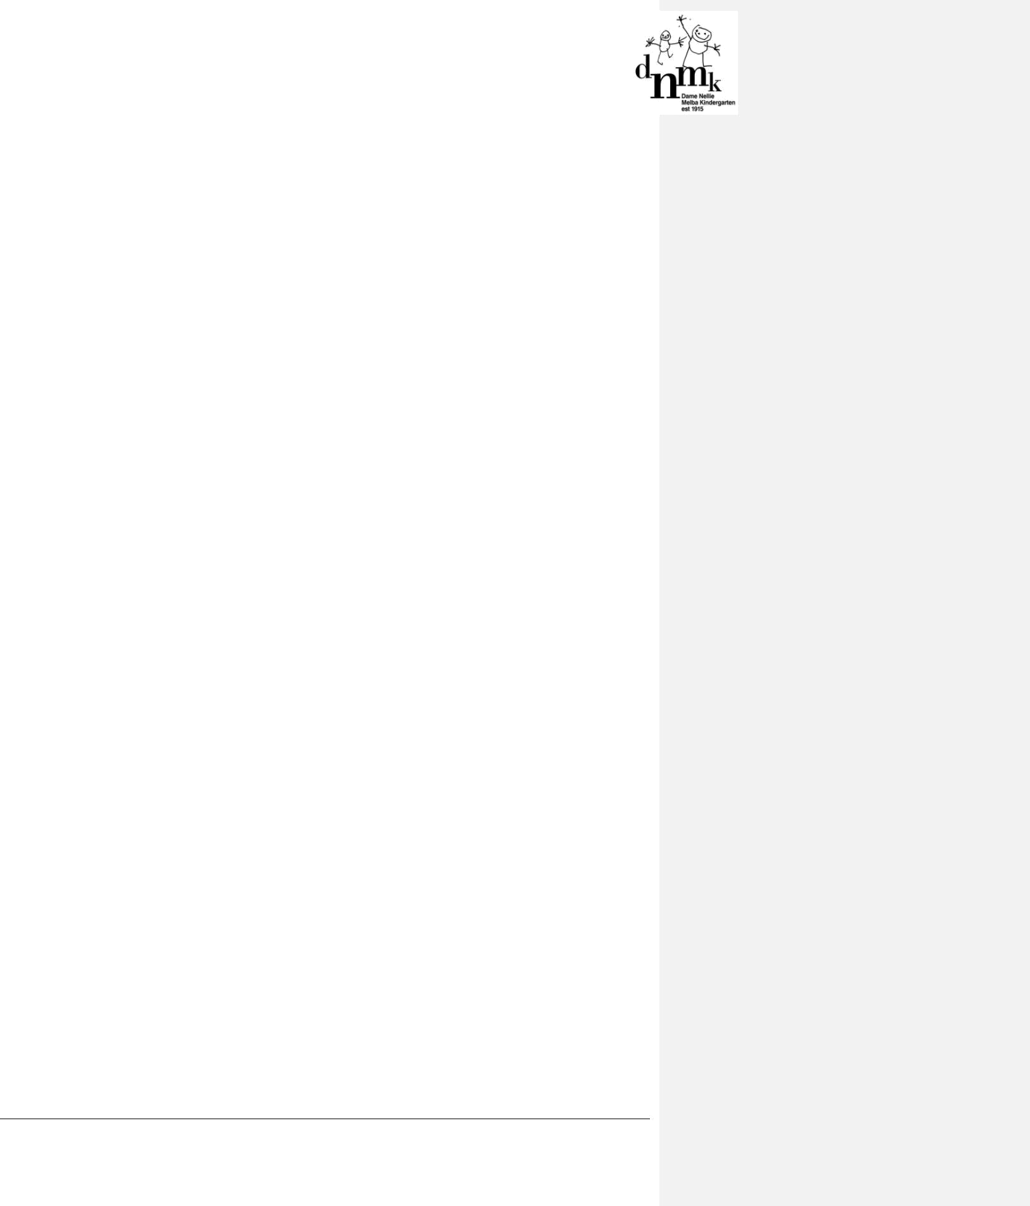

4. DEFINITIONS

The terms defined in this section relate specifically to this policy. For commonly used terms e.g. Approved Provider, Nominated Supervisor, Regulatory Authority etc. refer to the General Definitions section of this manual.

Bullying: Repeated verbal, physical, social or psychological behaviour that is harmful and involves the misuse of power by an individual or group towards one or more persons. Bullying occurs when one or more people deliberately and repeatedly upset or hurt another person, damage their property, reputation or social acceptance.

Duty of care: A common law concept that refers to the responsibilities of organisations to provide people with an adequate level of protection against harm and all reasonable foreseeable risk of injury.

Ethical conduct: Behavior which reflects values or a code of conduct.

Harassment: When someone is demeaning, derogatory or intimidating towards another person.

Harassment includes:

- racial taunts

- taunts about sexual orientation or gender identity

- sexual harassment: unwelcome physical, verbal or written behaviour of a sexual nature

- repeated insulting remarks.

Investigator: A person/staff member assigned or organization engaged with the responsibility of investigating suspected breaches of the Code of Conduct by the Approved Provider.

Notifiable complaint: A complaint that alleges a breach of the Education and Care Services National Act or Regulation, or alleges that the health, safety or wellbeing of a child at the service may have been compromised. Any complaint of this nature must be reported by the Approved Provider to the secretary of DET within 24 hours of the complaint being made (Section 174(2)(b), Regulation 176(2)(b)). Written reports to DET must include:

- details of the event or incident

- the name of the person who initially made the complaint

- if appropriate, the name of the child concerned and the condition of the child, including a medical or incident report (where relevant)

- contact details of a nominated member of the Grievances Subcommittee/investigator

- any other relevant information.

Written notification of complaints must be submitted via the National Quality Agenda IT system (NQAITS): http://www.acecqa.gov.au/national-quality-agenda-it-system. If the Approved Provider is unsure whether the matter is a notifiable complaint, it is good practice to contact DET for confirmation.

Respect: Demonstrating regard for the rights of individuals, for different values and points of views.

Serious incident: A serious incident is defined as (regulation 12):

- the death of a child -

– while being cared for by an education and care service; or

– following an incident while being educated and cared for by an education and care service

- any incident involving serious injury or trauma to, or illness of, a child while being educated and cared for by an education and care service -

– which a reasonable person would consider required urgent medical attention from a registered medical practitioner (examples include broken limbs or anaphylaxis reaction) attention of a registered medical practitioner; or

– for which the child attended, or ought reasonably to have attended a hospital.

DNMK Policies & Procedures Code of Conduct Policy – July, 2017

Page 3 of 14

- any incident where the attendance by emergency services at the education and care service premises was sought, or ought reasonably to have been sought

- any circumstances where a child being educated and cared for by an education and care service appears to be missing or cannot be accounted for;

– appears to have been taken or removed from the education and care services premises in a manner that contravenes National Regulations;

– is mistakenly locked in or locked out of the education and care service premises or any part of the premises.

The Regulatory Authority must be notified of a serious incident (section 174(2)(a)) in writing in the case of:

- the death of a child, as soon as practicable but within 24 hours of the death, or the time that the person becomes aware of the death

- any other serious incident, within 24 hours of the incident or the time that the person becomes aware of the incident

Written notification of serious incidents must be submitted via the ACECQA portal using the appropriate forms at http://acecqa.gov.au/notifications.

Support: Work in a co-operative and positive manner.

5. SOURCES AND RELATED POLICIES

Sources

- Early Childhood Australia, Code of Ethics: www.earlychildhoodaustralia.org.au

- United Nations, The Universal Declaration of Human Rights: http://www.un.org/en/universal-declaration-human-rights/

- United Nations, Convention on The Rights of the Child: http://www.unicef.org/crc/

- Victoria Legal Aid: www.legalaid.vic.gov.au

- Victorian Institute of Teaching – The Victorian Teaching Profession Code of Conduct and Code of Ethics: http://www.vit.vic.edu.au

Related policies

- Child Safe (formerly Child Protection) Policy

- Complaints and Grievances Policy

- Delivery and Collection of Children Policy

- Interactions with Children Policy

- Occupational Health and Safety Policy

- Privacy and Confidentiality Policy

- Relaxation and Sleep Policy

- Staffing Policy

RESPONSIBILITIES

The Approved Provider is responsible for:

- providing a safe environment for staff, contractors, volunteers, students on placement, parents/guardians, children and others attending the programs and activities of DNMK

- providing guidance through leadership and by being a positive role model

- developing and updating/ reviewing codes of conduct for DNMK in collaboration with the Nominated Supervisor, staff, parents/guardians, children and others involved with the service (refer to Attachments 1 and 3)

- ensuring that staff, volunteers, students and parents/guardians are provided with a copy of this policy on employment, engagement or enrolment at the service and that the current codes of conduct are publicly displayed and promoted to everyone including contractors and visitors

DNMK Policies & Procedures Code of Conduct Policy – July, 2017

Page 4 of 14

- ensuring that staff complete and sign the Code of Conduct Acknowledgement (refer to Attachment 2) and that these are filed with individual staff records upon engagement in the service

- ensuring that the codes of conduct are regularly discussed at staff meetings to reinforce expectations

- developing a culture of accountability within the service for complying with the code(s) of conduct and being prepared to respond when behavioural expectations are not adhered to

- ensuring that all children being educated and cared for at DNMK are protected from harm and any hazard likely to cause injury (National Law: Section 167) and that the children know who to speak to about any concerns and that their concerns are followed-up

- working with the Nominated Supervisor, staff, students, volunteers, parents/guardians and others at the service to provide an environment that encourages positive interactions, supports constructive feedback and holds one another to the codes of conduct

- ensuring that parents/guardians of a child attending the service can enter the service premises at any time that the child is being educated and cared for, except where this may pose a risk to the safety of children or staff, or conflict with any duty of care of the Approved Provider, Nominated Supervisor or educators under the Law (Regulation 157)

- ensuring that contractors, volunteers, parent/guardians, students or visitors at the service are not placed in a situation where they are left alone with a child

- respecting individual abilities, needs, cultural practices and beliefs in all interactions, both verbal and non-verbal

- notifying DET in writing within 24 hours of a serious incident (refer to Definitions) or of a notifiable complaint (refer to Definitions) at the service (National Law: Sections 174(2)(b) and 174(4), National Regulations: Regulations 175(2)(c) and 176(2)(b)) via the NQAITS

- referring notifiable complaints (refer to Definitions), grievances or complaints that are unable to be resolved appropriately and in a timely manner to the Grievances Subcommittee/investigator (refer to Complaints and Grievances Policy)

- activating the Complaints and Grievances Policy on notification of a breach of the Code of Conduct Policy

- taking appropriate disciplinary or legal action, or reviewing the terms of employment in the event of misconduct or a serious breach of the Code of Conduct Policy

- contacting Police in an emergency situation where it is believed that there is an immediate risk, such as when violence has been threatened or perpetrated or where sexual abuse or grooming is suspected as outlined in the Child Safe (formerly Child Protection) Policy.

The Nominated Supervisor is responsible for:

- ensuring that the children educated and cared for at DNMK are protected from harm and from any hazard likely to cause injury (National Law: Section 167)

- providing guidance through their leadership and by being a positive role model

- assisting the Approved Provider to develop codes of conduct for staff and parents/guardians, students, contractors, volunteers and visitors (refer to Attachments 1 and 3 for samples)

- completing and signing the Code of Conduct Acknowledgement for staff (refer to Attachment 2)

- adhering to the Code of Conduct for staff at all times

- informing the Approved Provider in the event of a serious incident (refer to Definitions), of a notifiable complaint (refer to Definitions) or of a breach of the Code of Conduct Policy

  - contacting Police in an emergency situation where it is believed that there is an immediate risk, such as when violence has been threatened or perpetrated, or where sexual abuse or grooming is suspected as outlined in the Child Safe (formerly Child Protection) Policy

- working with the Approved Provider, staff, students, volunteers, parents/guardians and others at the service to provide an environment that encourages positive interactions, supports constructive feedback and holds one another to the codes of conduct

DNMK Policies & Procedures Code of Conduct Policy – July, 2017

Page 5 of 14

  - ensuring that parents/guardians, students and volunteers sign the code of conduct (refer to Attachment 4)

  - ensuring that parents/guardians of a child attending the service can enter the service premises

at any time that the child is being educated and cared for, except where this may pose a risk to the safety of children or staff, or conflict with any duty of care of the Approved Provider, Nominated Supervisor or educators under the Law (Regulation 157)

- developing practices and procedures to ensure that parent/guardians, students, contractors, volunteers or visitors at the service, are not placed in a situation where they are left alone with a child

- respecting individual abilities, needs, cultural practices and beliefs in all interactions, both verbal and non-verbal

- understanding and accepting that serious breaches of this code will be deemed misconduct and may lead to disciplinary or legal action, or a review of their employment.

All staff are responsible for:

- assisting the Approved Provider to develop a code of conduct for staff (refer to Attachment 1)

- completing and signing the Code of Conduct Acknowledgement (refer to Attachment 2)

- adhering to the code of conduct for staff (refer to Attachment 1) at all times

- providing guidance to students, volunteers, parents/guardians, students and visitors through positive role modelling and, when appropriate, clear and respectful directions

- working with the Approved Provider, Nominated Supervisor, their colleagues, students, volunteers, parents/guardians and others at the service to provide an environment that encourages positive interactions, supports constructive feedback and holds one another to the codes of conduct

- ensuring that parents/guardians, students, contractors, volunteers and visitors at the service are not placed in a situation where they are left alone with a child

- informing the Approved Provider in the event of a serious incident (refer to Definitions), of a notifiable complaint (refer to Definitions) or of a breach of the Code of Conduct Policy

- contacting Police in an emergency situation where it is believed that there is an immediate risk, such as when violence has been threatened or perpetrated or where sexual abuse or grooming is suspected as outlined in the Child Safe (formerly Child Protection) Policy.

- respecting individual abilities, needs, cultural practices and beliefs in all interactions, both verbal and non-verbal

- understanding and accepting that serious breaches of this code will be deemed misconduct and may lead to disciplinary or legal action, or a review of their employment.

Parents/guardians are responsible for:

- reading the Code of Conduct Policy

- completing and signing the Code of Conduct for parents/guardians (refer to Attachments 3 and 4)

- abiding by the Code of Conduct for parents/guardians

- complying with all policies of the service.

Students, contractors, volunteers and visitors while at the service, are responsible for following this policy and its procedures.

EVALUATION

In order to assess whether the values and purposes of the policy have been achieved, the Approved Provider will:

- regularly seek feedback from everyone affected by the policy regarding its effectiveness

- monitor the implementation, compliance, complaints and incidents in relation to this policy

- assess whether a satisfactory resolution has been achieved in relation to issues arising from this policy

DNMK Policies & Procedures Code of Conduct Policy – July, 2017

Page 6 of 14

- keep the policy up to date with current legislation, research, policy and best practice

- revise the policy and procedures as part of the service’s policy review cycle, or as required

- notify parents/guardians at least 14 days before making any changes to this policy or its procedures.

ATTACHMENTS

- Attachment 1: Code of Conduct for Approved Provider, Nominated Supervisor and all staff

- Attachment 2: Code of Conduct Acknowledgement for staff

- Attachment 3: Code of Conduct for parents/guardians, students, contractors and volunteers

- Attachment 4: Code of Conduct Acknowledgement for parents/guardians, students, contractors and volunteers

AUTHORISATION

This policy was adopted by the Approved Provider of July, 2017

REVIEW DATE: JULY, 2018

DNMK Policies & Procedures Code of Conduct Policy – July, 2017

Page 7 of 14
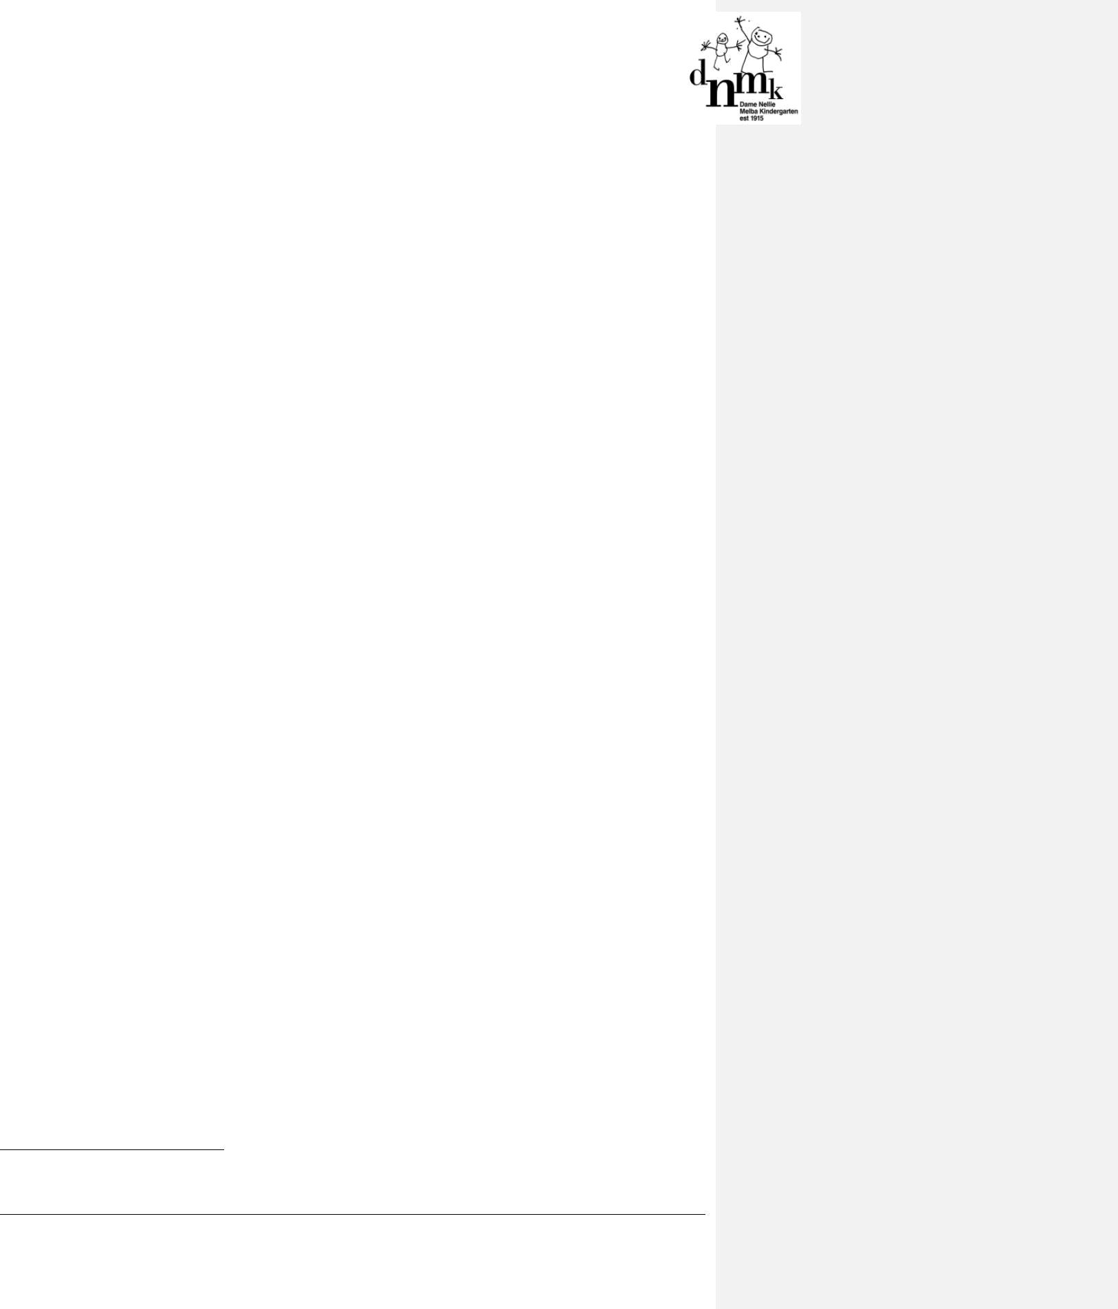

ATTACHMENT 1

Code of conduct for the Approved Provider, Nominated Supervisor and all staff¹

At DNMK, our philosophy is build upon respect for the rights of children, their families and our colleagues. This underpins everything that we do.

We share an excitement and enthusiasm about the positive impact we can have on children's development and know that working collaboratively as a team and modelling ethical behaviour is paramount.

This document sets out professional standards for our relationships with children, families and colleagues. In signing this document we are committing to uphold these standards and to seeking support if needed.

The Approved Provider, Nominated Supervisor and all staff at DNMK are responsible for promoting the safety and wellbeing of children and their families by:

welcoming all children and their families and being inclusive

- treating everyone with respect, including listening to and valuing their ideas and opinions

- contributing to a culture of child safety

- adhering to the Child Safe (formerly Child Protection) Policy and all other policies

- taking all reasonable steps to protect children from abuse

- respecting the privacy of children and their families, and only disclosing information to people who have a need to know as required under the Privacy and Confidentiality Policy

- reporting and acting on any breaches of this Code of Conduct, complaints or concerns.

Professional responsibilities

The Approved Provider, Nominated Supervisor and all staff demonstrate our commitment to our professional responsibilities by:

undertaking duties in a competent, timely and responsible way

- ensuring our knowledge and expertise is up to date and relevant to our roles

- being aware of the role of other professionals and agencies and working collaboratively and within the limits of our professional expertise

- understanding and complying with legal obligations in relation to:

  - discrimination, harassment and vilification

  - negligence

  - grooming

  - disclosure of child sexual abuse

  - protection of a child from child sexual abuse

  - mandatory reporting

  - privacy and confidentiality

  - occupational health and safety, including emergency evaluation procedures

  - raising any complaints or grievances in accordance with the Complaints and Grievances Policy

  - maintaining teacher registration and Working with Children checks as applicable.

- raising any complaints or grievances in accordance with the Complaints and Grievances Policy.

- This attachment was informed by the Victorian Institute of Teaching’s The Victorian Teaching Profession Code of Conduct and A Guide for Creating A Child Safe Organisation, available from the Commission for Children and Young People (refer to Sources)

DNMK Policies & Procedures Code of Conduct Policy – July, 2017

Page 8 of 14
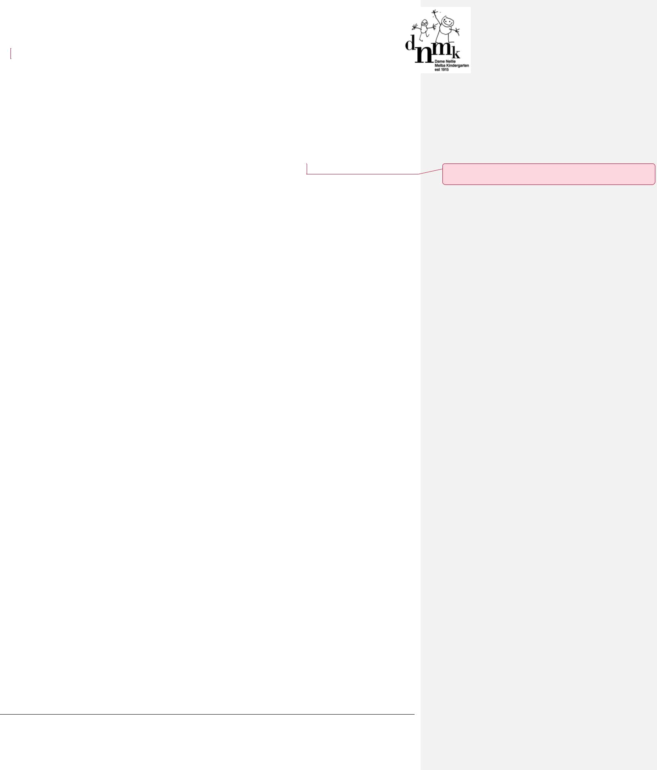

- ensuring that safety and hygiene practices are adhered to at all times. For example, if taking a hot beverage into a room or outdoor area, ensure that this is below a temperature that may cause injury should it be spilt.

- maintaining a professional manner at all times, including not receiving any unrelated personal calls on the DNMK phone line or on personal mobile phones during session times. (The DNMK phone number should only be given out by staff as a staff members child’s school emergency contact, or to any others who may need to contact the staff member in times of an emergency).

The code of conduct professional standards for staff apply to all interactions, both verbal and non verbal, in person, via phone, email, social media and the DNMK website.

Relationships with children

The Approved Provider, Nominated Supervisor and all staff at DNMK demonstrate our commitment to high-quality education and care for children by:

- encouraging children to express themselves and their opinions

- allowing children to undertake experiences that develop self-reliance and self-esteem

- maintaining a safe environment for children

- being a positive role model at all times

- speaking to children in an encouraging and positive manner

- giving each child positive guidance and encouraging appropriate behaviour

- providing opportunities for children to interact and develop respectful and positive relationships with each other, and with other staff members and volunteers at the service

- regarding all children equally, and with respect and dignity

- having regard to their cultural values and supporting them to express their culture

- respecting individual difference including age, physical and intellectual development, and catering for the abilities of each child at the service

- working with children in an open and transparent way by informing other staff about the work being done with children

- encouraging and assisting children to undertake activities of a personal nature for themselves e.g. toileting and changing clothes

- informing children if physical contact is required for any purpose, asking them if they are comfortable with this interaction and complying with the Interactions with Children policy.

Relationships with parents/guardians and families

In our relationships with parents/guardians and families, the Approved Provider, Nominated Supervisor and all staff demonstrate our commitment to collaboration by:

- working collaboratively with parents/guardians and families

- considering the perspective of parents/guardians and families when making decisions that impact on the education and care of their child

- communicating with parents/guardians and families in a timely and sensitive manner

- responding to concerns expressed by parents/guardians and families in a timely and appropriate manner.

Relationships with employer and between colleagues

In relationships with the Approved Provider, Nominated Supervisor and between colleagues, staff demonstrate collegiality by:

- encouraging others to act in accordance with this Code of Conduct and taking action when they observe behaviours which are outside of the Code of Conduct

- developing relationships based on mutual respect, equity and fairness

- working in partnership in a courteous, respectful and encouraging manner

DNMK Policies & Procedures Code of Conduct Policy – July, 2017

Page 9 of 14

Commented [SL1]: This section has the most changes, please review carefully

- valuing the input of others

- sharing expertise and knowledge in appropriate forums, and in a considered manner

- respecting the rights of others as individuals

- giving encouraging and constructive feedback, and respecting the value of different professional approaches

- being prepared to have difficult conversations and use constructive processes to address differences of opinion.

DNMK Policies & Procedures Code of Conduct Policy – July, 2017

Page 10 of 14
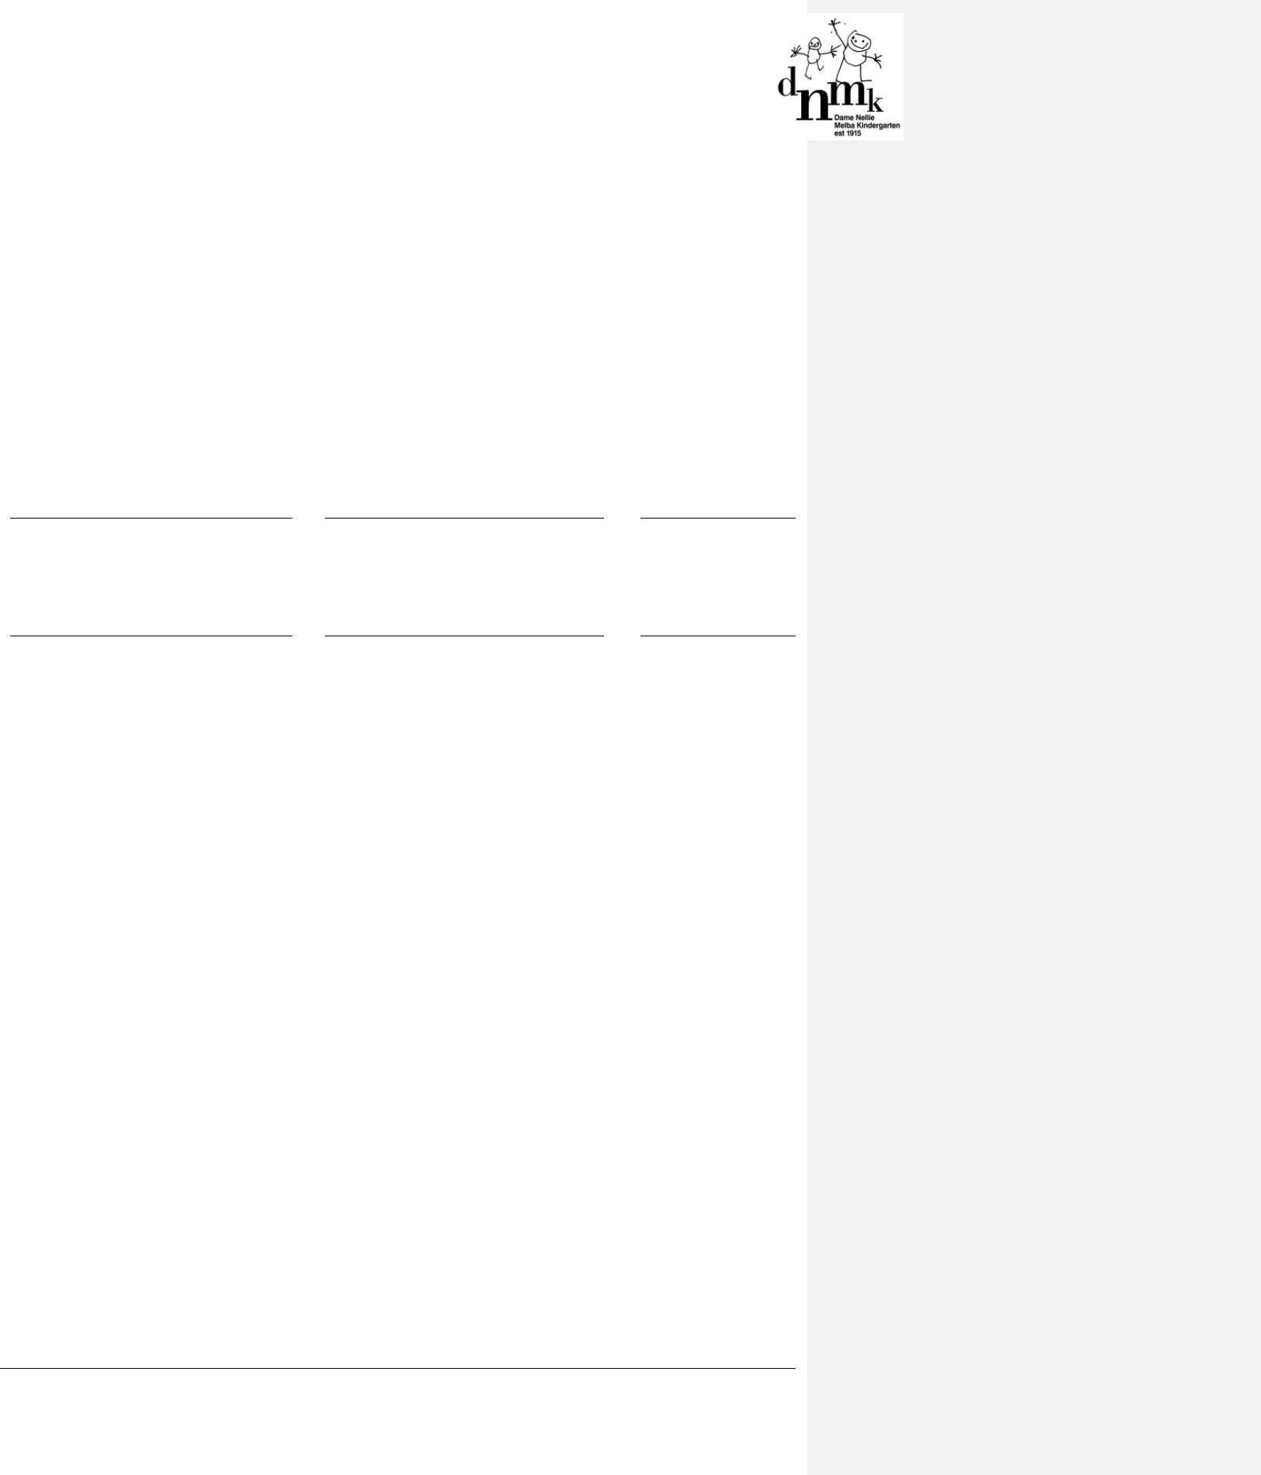

ATTACHMENT 2

Code of Conduct Policy Acknowledgement for staff

I hereby acknowledge that on DNMK.

date, I received a copy of the Code of Conduct Policy for

I have read the policy and I understand its contents.

I commit to abiding by the Code of Conduct and fulfilling my responsibilities as outlined in this policy whilst working at DNMK.

I understand that the Approved Provider will address any breach of this policy, and that any serious breach could lead to disciplinary or legal action.

Signature Name (please print) Date

Witness signature Name (please print) Date

Thank you for your contribution to making DNMK an open, safe, welcoming and friendly environment.

DNMK Policies & Procedures Code of Conduct Policy – July, 2017

Page 11 of 14

ATTACHMENT 3

Code of conduct for parents/guardians, students, volunteers, contractors and visitors

I commit to contributing to creating an environment at DNMK that:

- respects the rights of the child and values diversity

- acknowledges the vulnerability of Aboriginal children, children from a culturally and linguistically diverse background and children with a disability and has zero tolerance of discrimination

- maintains a duty of care (refer to Definitions) towards all children at the service

- is committed to the safety and wellbeing of each child at the service

- is committed to the safety and wellbeing of all staff at the service

- provides a safe and secure environment for all at the service

- provides an open, welcoming environment in which everyone’s contribution is valued and respected

- is committed to communicating openly and honestly

- is committed to continually learning how to be inclusive and respectful of cultural needs

- encourages parents/guardians, volunteers, students and community members to support and participate in the program and activities of the service.

Relationships with children

In our relationships with children, I commit to:

- being a positive role model at all times

- encouraging children to express themselves and their opinions

- allowing children to undertake experiences that develop self-reliance and self-esteem

- maintaining a safe environment for children

- speaking to children in an encouraging and positive manner

- giving each child positive guidance and encouraging appropriate behaviour

- regarding all children equally, and with respect and dignity

- having regard to each child’s cultural values

- respecting individual difference including age, physical and intellectual development, and catering for the abilities of each child at the service.

Relationships with the Approved Provider, Nominated Supervisor, staff and others

In my relationships with the Approved Provider, Nominated Supervisor, staff, other parents/guardians, volunteers and visitors I commit to:

- reading and abiding by the Code of Conduct Policy

- developing relationships based on mutual respect

- working in partnership in a courteous, respectful and encouraging manner

- valuing the input of others

- sharing our expertise and knowledge in a considered manner

- respecting the rights of others as individuals

- giving encouraging and constructive feedback, and respecting the value of different professional approaches

- respecting the privacy of children and their families and only disclosing information to people who have a need to know as required under the Privacy and Confidentiality policy

- following the directions of staff at all times

- treating the kindergarten environment with respect

DNMK Policies & Procedures Code of Conduct Policy – July, 2017

Page 12 of 14

- raising any concerns, including concerns about safety, as soon as possible with staff to ensure that they can be resolved efficiently

- raising any complaints or grievances in accordance with the Complaints and Grievances Policy.

DNMK Policies & Procedures Code of Conduct Policy – July, 2017

Page 13 of 14
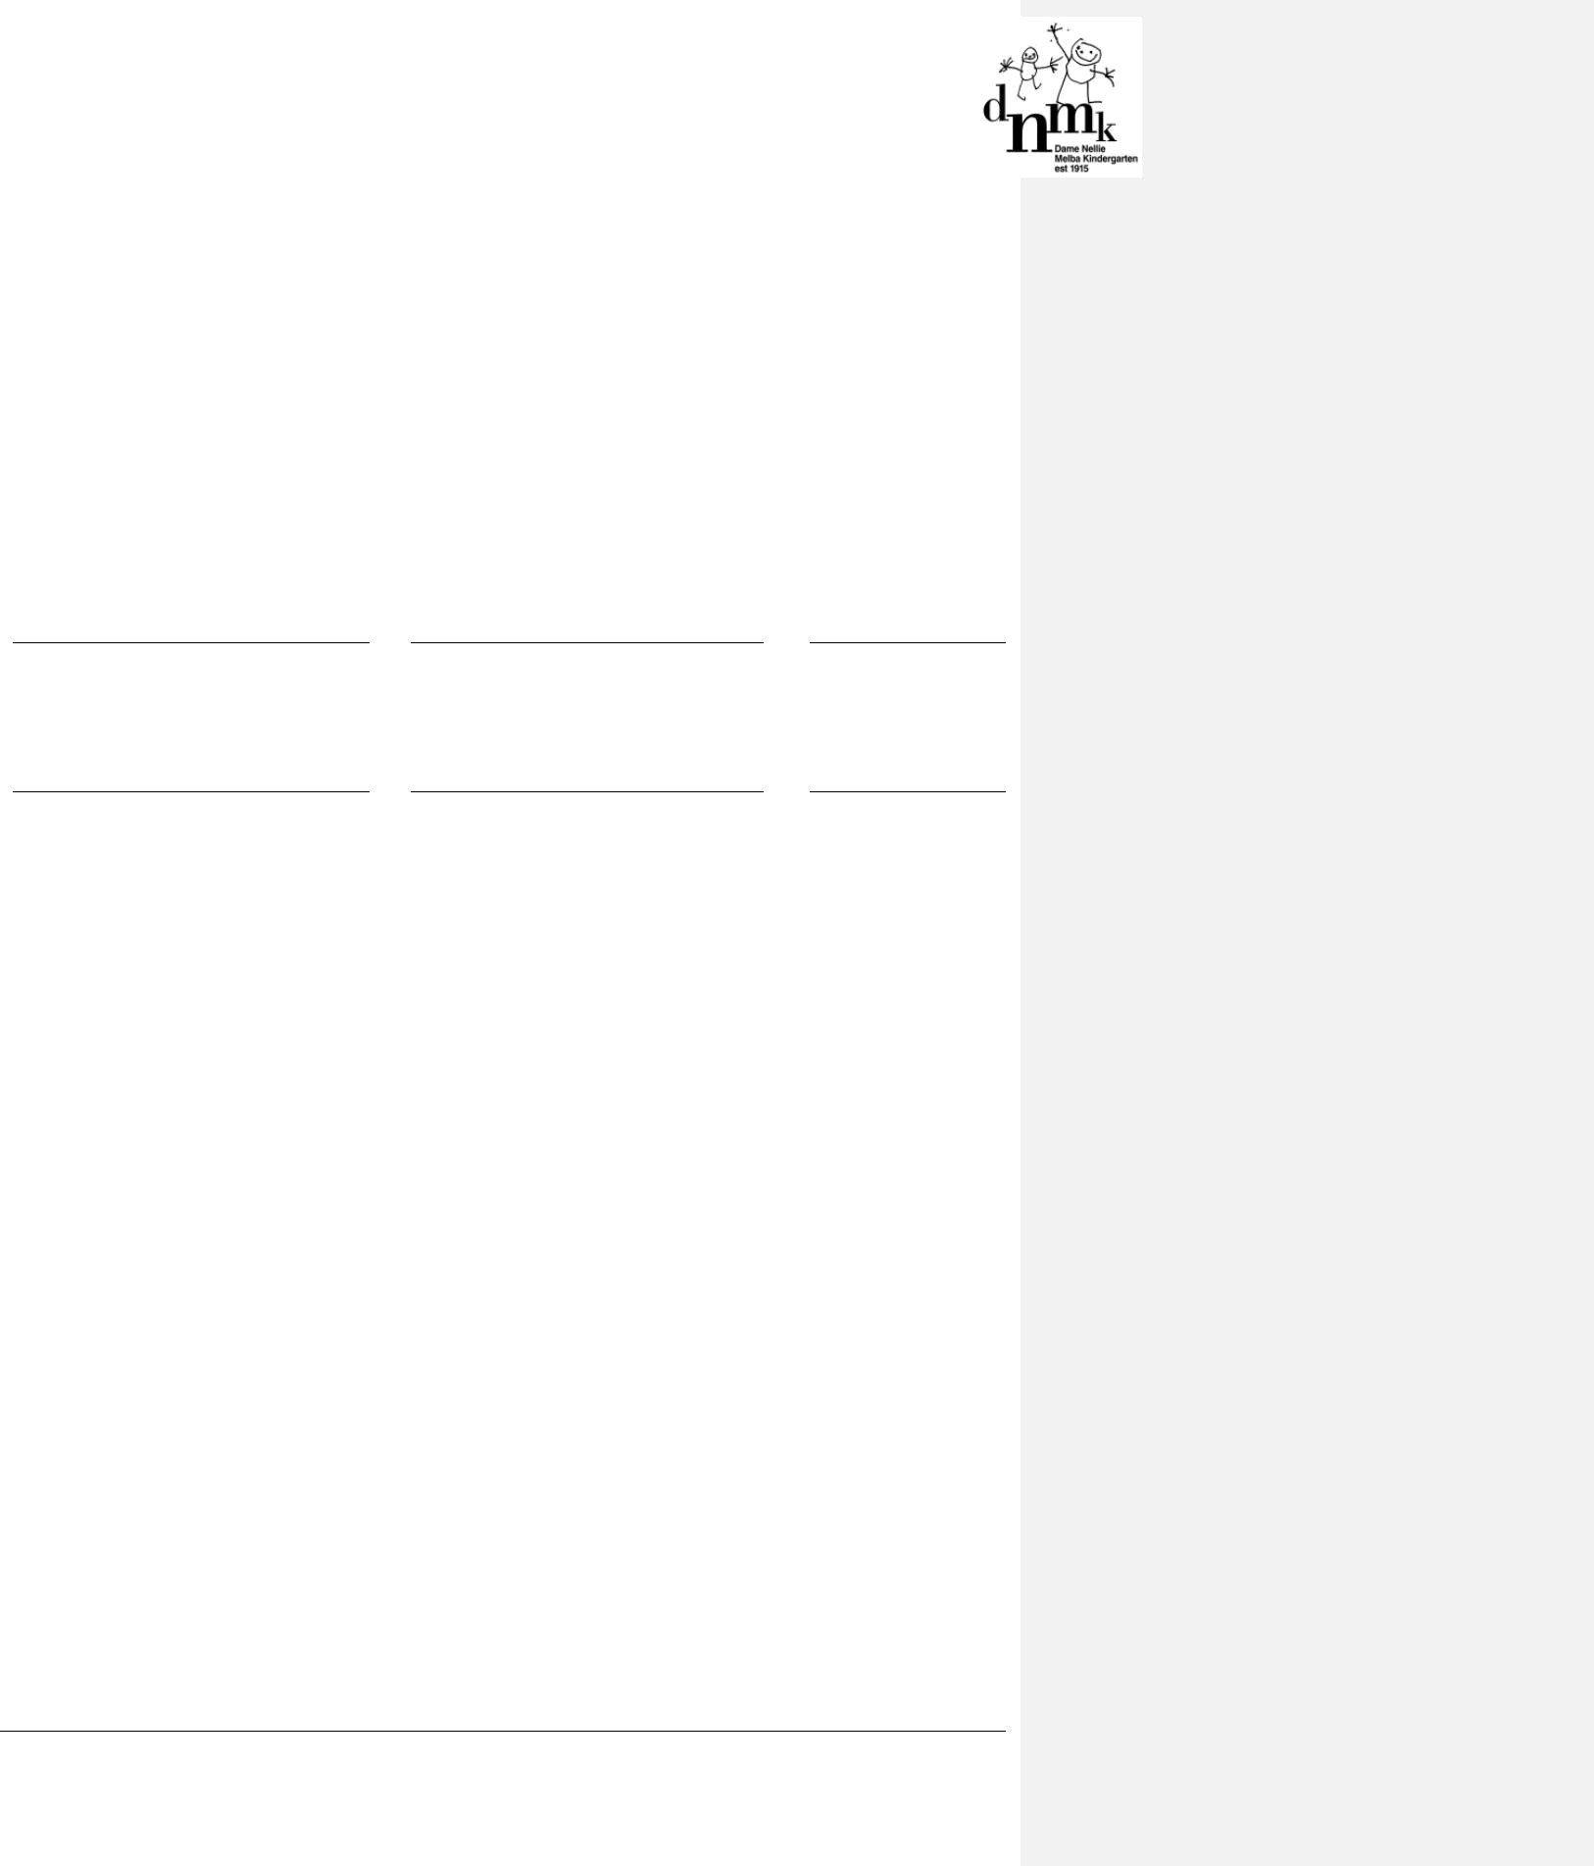

ATTACHMENT 4

Code of Conduct Policy Acknowledgement for parents/guardians, students, contractors and volunteers

I hereby acknowledge that on [Date], I received a copy of the Code of Conduct Policy for DNMK.

I have read this policy and understand its contents. I commit to abiding by the Code of Conduct and fulfilling my responsibilities as outlined in this policy whilst my child is attending DNMK.

I agree to abide by the values, principles and practices set out within.

I understand that a breach of the Code of Conduct may lead to limitations being placed on my attendance at the service.

Signature Name (please print) Date

Witness signature Name (please print) Date

Thank you for your contribution to making DNMK an open, safe, welcoming and friendly environment.

DNMK Policies & Procedures Code of Conduct Policy – July, 2017

Page 14 of 14

