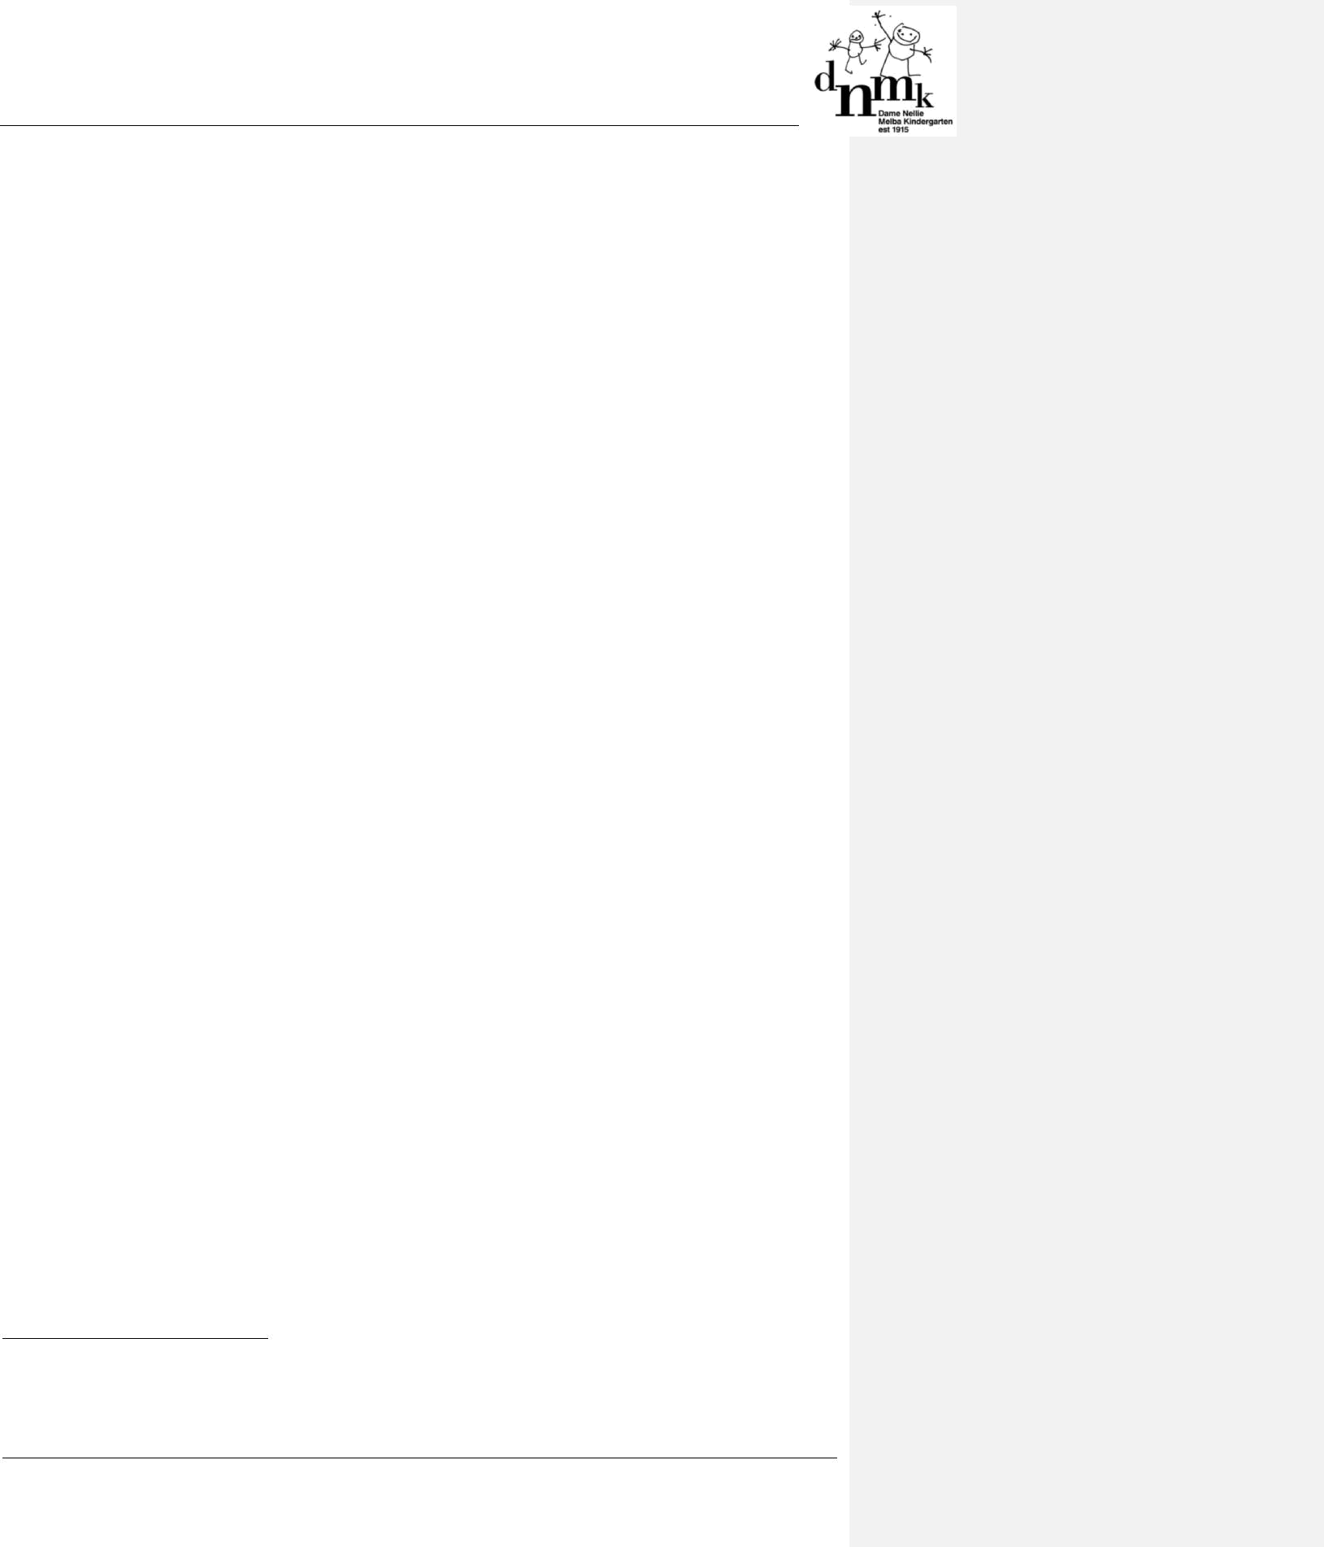

ADMINISTRATION OF MEDICATION POLICY

Best Practice – Quality Area 2

PURPOSE

This policy will clearly define the:

- procedures to be followed when a child requires medication while attending DNMK

- responsibilities of educators, parents/guardians and the Approved Provider to ensure the safe administration of medication at DNMK.

POLICY STATEMENT

1. VALUES

DNMK is committed to:

- providing a safe and healthy environment for all children, educators, staff and other persons attending the service

- responding immediately to the needs of a child who is ill or becomes ill while attending the service

- ensuring safe and appropriate administration of medication in accordance with legislative and regulatory requirements.

2. SCOPE

This policy covers the administration of both prescribed and non-prescribed medication at DNMK, including during offsite excursions and activities.

This policy applies to the Approved Provider, Nominated Supervisor, Certified Supervisor, educators, staff, students on placement, volunteers, parents/guardians, children and others attending the programs and activities of DNMK.

3. BACKGROUND AND LEGISLATION

Background

Medication (including prescription, non-prescription, over-the-counter and homeopathic medications) must not be administered to a child at a service without the authorisation of a parent/guardian or person with the lawful authority to consent to the administration of medical attention to the child. In the case of an emergency, it is acceptable to obtain verbal consent from a parent/guardian, or to obtain consent from a registered medical practitioner or medical emergency services if the child’s parent/guardian cannot be contacted. In the case of an anaphylaxis or asthma emergency, medication may be administered to a child without authorisation following the direction of the child’s medical management plan. In this circumstance, the child’s parent/guardian and/or emergency services must be contacted as soon as possible (Regulation 94)¹. When educators are required to administer medication, they must abide by specific regulatory requirements, such as written consent, and must follow the guidelines of this policy and the procedures outlined in Attachment 1 – Procedures for the safe administration of medication.

A medication record² must be completed with the following information:

- the name of the child the authorisation to administer medication (including self-administration, if applicable) signed by a parent/guardian or a person named in the child's enrolment record as authorised to consent to administration of medication

- the name of the medication to be administered

- the time and date the medication was last administered

- the time and date or the circumstances under which the medication should be next administered

- the dosage of the medication to be administered

- Guide to the Education and Care Services National Law and the Education and Care Services National Regulations 2011, p.63

- A template of a medication record can be downloaded from: www.acecqa.gov.au

DNMK Policies & Procedures

Administration of Medication Policy

Page 1 of 9

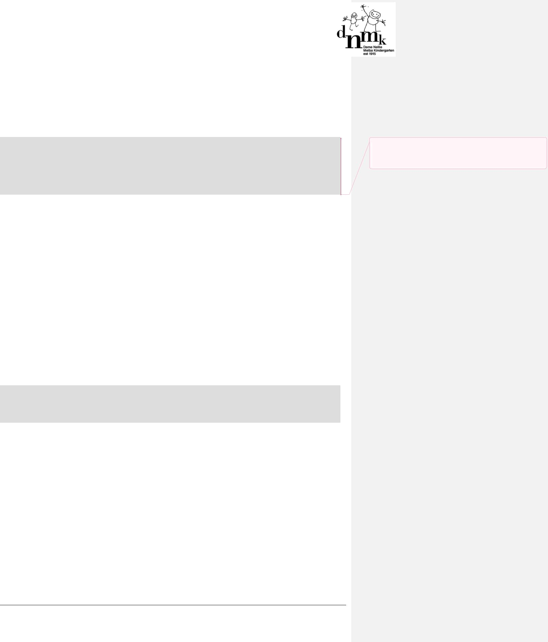

- the manner in which the medication is to be administered

- if the medication is administered to the child:

  - the dosage that was administered

  - the manner in which the medication was administered

  - the time and date the medication was administered

  - the name and signature of the person who administered the medication

  - the name and signature of the person who checked the dosage, if another person is required under Regulation 95 to check the dosage and administration of the medication.

Services who provide education and care to a child over preschool age (as defined in the Education and Care Services National Regulations 2011) may allow a child over preschool age to self-administer medication. Where a service chooses to allow self-administration of medication, the Approved Provider must consider the risks associated with this practice and their duty of care, and develop appropriate guidelines to clearly specify the circumstances under which such permission would be granted and the procedures to be followed by staff at the service.

Legislation and standards

Relevant legislation and standards include but are not limited to:

- Education and Care Services National Law Act 2010

- Education and Care Services National Regulations 2011

  - Specific Regulations: 92, 93, 94, 95, 96

  - Related Regulations: 90, 91, 160, 161, 162, 168, 177, 178, 181–184

- Health Records Act 2001 (Vic)

- National Quality Standard, Quality Area 2: Children’s Health and Safety

  - Standard 2.1: Each child’s health is promoted − Elements 2.1.1 and 2.1.4

- Occupational Health and Safety Act 2004 (Vic)

- Public Health and Wellbeing Act 2008 (Vic)

- Public Health and Wellbeing Regulations 2009 (Vic)

- Therapeutic Goods Act 1989 (Cth)

The most current amendments to listed legislation can be found at:

  - Victorian Legislation – Victorian Law Today: http://www.legislation.vic.gov.au/

  - Commonwealth Legislation – ComLaw: http://www.comlaw.gov.au/

- DEFINITIONS

Approved first aid qualification: A list of approved first aid qualifications, anaphylaxis management and emergency

asthma management training is published on the ACECQA website: www.acecqa.gov.au

Illness: Any sickness and/or associated symptoms that affect the child’s normal participation in the activities or program at the service.

Infectious disease: A disease that can be spread, for example, by air, water or interpersonal contact. An infectious disease is designated under Victorian Law or by a health authority (however described) as a disease that would require the infected person to be excluded from an education and care service.

Injury: Any harm or damage to a person.

Medication (prescribed): Medicine, as defined in the Therapeutic Goods Act 1989 (Cth), that is:

- authorised by a health care professional

DNMK Policies & Procedures Administration of Medication Policy
Page 2 of 9

Commented [SL1]: Adam, I have removed the references to children over pre-school age self administering medication from this policy as they were included as an option through out, however are not relevant in our context


- dispensed by a health care professional with a printed label that includes the name of the child being prescribed the medication, the medication dosage and expiry date.

Medication (non-prescribed): Over-the-counter medication, including vitamins and cultural herbs or homeopathic medications that may have been recommended by an alternative health care professional such as a naturopath.

Medication record: Contains details for each child to whom medication is to be administered by the service. This includes the child’s name, signed authorisation to administer medication and a record of the medication administered, including time, date, dosage, manner of administration, name and signature of person administering the medication and of the person checking the medication, if required (Regulation 92). A sample medication record is available on the ACECQA website.

5. SOURCES AND RELATED POLICIES

Sources

- VMIA Insurance Guide, Community Service Organisations program: www.vmia.vic.gov.au

- Guide to the Education and Care Services National Law and the Education and Care Services National Regulations 2011 (ACECQA, Oct 2011)

- Guide to the National Quality Standard (ACECQA, Oct 2011)

- Staying Healthy: Preventing infectious diseases in early childhood education and care services (5th edition, 2013)

National Health and Medical Research Council: http://www.nhmrc.gov.au/guidelines/publications/ch55

- Anaphylaxis Australia: www.allergyfacts.org.au/foodalerts.asp

- Asthma Australia: www.asthmaaustralia.org.au

- The Asthma Foundation of Victoria: www.asthma.org.au or phone (03) 9326 7088 or 1800 645 130 (toll free)

- HealthInsite: www.healthinsite.gov.au

- Immunise Australia Program: www.immunise.health.gov.au

- National Health and Medical Research Council (NHMRC): www.nhmrc.gov.au

- NPS Medicine Wise: www.nps.org.au

Service policies

- Asthma Policy

- Dealing with Medical Conditions Policy

- Administration of First Aid Policy

- Excursions and Service Events Policy

- Incident, Injury, Trauma and Illness Policy

- Anaphylaxis Policy

- Dealing with Infectious Diseases Policy

- Privacy and Confidentiality Policy

- Enrolment and Orientation Policy

PROCEDURES

The Approved Provider is responsible for:

- ensuring that medication is not administered to a child being educated and cared for by the service unless it is authorised, and the medication is administered in accordance with the procedures prescribed in Regulation 95

- ensuring that if a child over preschool age at the service is permitted to self-administer medication (Regulation 96), an authorisation for the child to self-administer medication is recorded in the medication record for the child

- ensuring that a medication record that meets the requirements set out in Regulation 92(3) is available at all times for recording the administration of medication to children at the service (Regulation 92). (Refer to the template Medication Record (p.171) in the Guide to the Education and Care Services National Law and the Education and Care Services National Regulations 2011 or visit: www.acecqa.gov.au ensuring that parents/guardians are given

DNMK Policies & Procedures

Administration of Medication Policy

Page 3 of 9

written notice as soon as is practicable if medication has been administered in an emergency and where authorisation has been given verbally (Regulation 93(2))

- ensuring that the parent/guardian of the child and emergency services are notified as soon as is practicable when medication has been administered in an anaphylaxis or asthma emergency (Regulation 94(2))

- ensuring that at least one educator on duty has a current approved first aid qualification (Regulation 136). (Note: this is a minimum requirement. As a demonstration of duty of care and best practice, ELAA recommends that all educators have current approved first aid qualifications.)

- developing and reviewing procedures for the authorisation and administration of medication required for the treatment or management of long-term conditions (see Attachment 1 – Procedures for the safe administration of medication)

- ensuring that all educators are familiar with the procedures for the administration of medication

- ensuring that medication records are kept and stored securely until the end of 3 years after the last date on which the child was educated and cared for by the service (Regulation 183(2)(d))

The Nominated Supervisor is responsible for:

- ensuring that medication is only given to a child where authorisation has been provided, and medication is administered in accordance with legislation and this policy (Regulation 93(3))

- ensuring that the parent/guardian of the child and emergency services are notified as soon as is practicable when medication has been administered in an anaphylaxis or asthma emergency (Regulation 94(2))

- ensuring that medication is not accessible to children and is stored in a childproof container (including in the refrigerator for medications requiring refrigeration)

- being aware of children who require medication for ongoing conditions or in emergencies, and ensuring that the medical management plans are completed and attached to the child’s enrolment form, and displayed for use by those caring for children (being sensitive to privacy requirements)

- documenting situations in which an authorised person has provided verbal authorisation but has refused to confirm the authorisation in writing (these notes are to be kept with the child’s enrolment record)

- informing parents/guardians as soon as is practicable if an incident occurs in which the child was administered the incorrect medication or incorrect dose as prescribed in the medication record, staff forgot to administer the medication or the medication was administered at the wrong time. Staff must also ensure that any medication that is accidentally dropped is not administered to a child or returned to the original container, and that parents/guardians are informed if an incident of this nature occurs

- informing parents/guardians that non-prescribed medication (with the exception of sunscreen) will only be administered for a maximum of 48 hours, after which a medical management plan from a doctor will be required for its continued use

- informing parents/guardians that paracetamol is not supplied by DNMK and that the administration of paracetamol will be in line with the administration of all other medication (refer to Attachment 2 – Administration of paracetamol).

Certified Supervisors and other educators are responsible for:

- ensuring that each child’s enrolment form provides details of the name, address and telephone number of any person who has lawful authority to request and permit the administration of medication to the child (Regulation 160(3)(iv))

- administering medication in accordance with Regulation 95 and the guidelines set out in Attachment 1 – Procedures for the safe administration of medication

- communicating with parents/guardians about the procedures outlined in this policy and the parent/guardian responsibilities when requesting medication be administered to their child, and making the medication record available for parents/guardians to record information during operational hours

- ensuring that all details in the medication record have been completed by parents/guardians/authorised persons in accordance with Regulation 92(3) prior to administering medication

- obtaining verbal authorisation for the administration of medication from the child’s parents/guardians/authorised person (as recorded in the child’s enrolment record), or a registered medical practitioner or medical emergency services when an authorised person cannot reasonably be contacted in an emergency (Regulation (93)(5)(b))

DNMK Policies & Procedures

Administration of Medication Policy

Page 4 of 9

- ensuring that two staff members, one of whom must be an educator, are present when verbal permission to administer medication is received, and that details of this verbal authorisation are completed in the medication record

- ensuring that verbal permission is followed up with a written authorisation as soon as is practicable

- ensuring that parents/guardians take all medication home at the end of each session/day.

Parents/guardians are responsible for:

- ensuring that any medication to be administered is recorded in the medication record kept at the service premises

- providing a current medical management plan when their child requires long-term treatment of a condition that includes medication, or their child has been prescribed medication to be used for a diagnosed condition in an emergency

- ensuring that the details of authorised persons are kept up to date in the child’s enrolment form

- ensuring that prescribed medications to be administered at the service are provided in their original container with the label intact, bearing the child’s name, dosage, instructions and the expiry date (Regulation 95(a)(i))

- ensuring that prescribed medications to be administered at the service are within their expiry date

- physically handing the medication to a staff member and informing them of the appropriate storage and administration instructions for the medication provided

- clearly labelling non-prescription medications and over-the-counter products (for example sun block and nappy cream) with the child’s name. The instructions and use-by dates must also be visible

- ensuring that no medication or over-the-counter products are left in their child’s bag or locker

- taking all medication home at the end of each session/day

- informing the service if any medication has been administered to the child before bringing them to the service, and if the administration of that medication is relevant to or may affect the care provided to the child at the service

- ensuring that their child’s enrolment details are up to date, and providing current details of persons who have lawful authority to request or permit the administration of medication.

Volunteers and students, while at the service, are responsible for following this policy and its procedures.

EVALUATION

In order to assess whether the values and purposes of the policy have been achieved, the Approved Provider will:

- regularly seek feedback from everyone affected by the policy regarding its effectiveness

- monitor the implementation, compliance, complaints and incidents in relation to this policy

- keep the policy up to date with current legislation, research, policy and best practice

- revise the policy and procedures as part of the service’s policy review cycle, or as required

- notify parents/guardians at least 14 days before making any changes to this policy or its procedures.

ATTACHMENTS

- Attachment 1: Procedures for the safe administration of medication

  - Attachment 2: Administration of paracetamol

  - Attachment 3: Medication Record

AUTHORISATION

This policy was adopted by the Approved Provider of DNMK September 2016

REVIEW DATE: SEPTEMBER 2017

DNMK Policies & Procedures

Administration of Medication Policy

Page 5 of 9

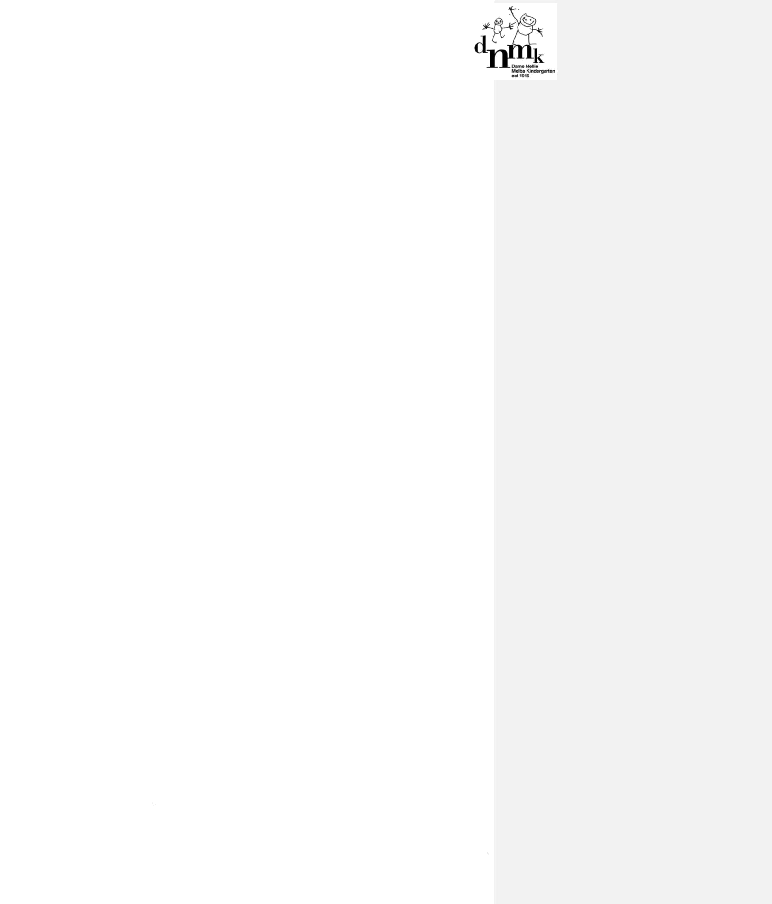

ATTACHMENT 1

Procedures for the safe administration of medication

Two persons (one of whom must be an educator) are responsible for the administration of any medication³. At least one of these persons must hold a current approved first aid qualification.

One person will check the details (including dosage and the identity of the child who is given the medication) and witness its administration, while the other person will administer the medication (Regulation 95(c)). Before administering any medication to a child, it is extremely important for staff to check if the child has any allergies to the medication being administered.

Procedure for administration of medication

- Wash and dry hands thoroughly before administering any medication. If appropriate, gloves are recommended wherever possible.

- Check the medication record to confirm date, time, dosage and the child to whom the medication is to be administered.

- Check that prescription medication:

- is in its original container, bearing the original label and instructions

- is the correct medication, as listed in the medication record

- has the child’s name on it (if the medication was prescribed by a registered medical practitioner)

- is the required dosage, as listed in the medication record

- has not passed its expiry date.

- Check that non-prescription medication:

- is in the original container, bearing the original label and instructions

- is the correct medication, as listed in the medication record

- has the child’s name on it

- is the required dosage, as listed in the medication record

- has not passed its expiry date.

5. When administering the medication, ensure that:

- the identity of the child is confirmed and matched to the specific medication

- the correct dosage is given

- the medication is administered in accordance with the instructions attached to the medication, or any written or verbal instructions provided by a registered medical practitioner

- both staff members complete the medication record (Regulation 92(3)(h)) and store any remaining medication appropriately, such as in the refrigerator if required

- the Nominated Supervisor or Certified Supervisor informs the parent/guardian on arrival to collect the child that medication has been administered and ensures that the parent/guardian completes the required details in the medication record.

Administration of medication for ongoing medical conditions

Where a child is diagnosed with a condition that requires ongoing medication or medication to be administered in emergencies, parents/guardians may authorise the administration of the medication for a defined period (up to six months). In these cases:

- a medical management plan completed by the child’s doctor should be provided and attached to the child’s enrolment form (or on display, where appropriate)

- the medical management plan should define:

- Note: under Regulation 95(c), this is not a requirement in an education and care service that is permitted to have only one educator to educate and care for children.

DNMK Policies & Procedures

Administration of Medication Policy

Page 6 of 9

  - the name of the medication, dosage and frequency of administration

  - conditions under which medication should be administered

  - what actions, if any, should be taken following the administration of the medication

- when medication is required under these circumstances, educators/staff should:

  - follow the procedures listed above

  - ensure that the required details are completed in the medication record

  - notify the parents as soon as is practicable.

Refer to the Dealing with Medical Conditions Policy for further information.

DNMK Policies & Procedures

Administration of Medication Policy

Page 7 of 9

ATTACHMENT 2

Administration of paracetamol

There may be times when a child develops a fever while at the service. When this occurs, there may be a need to administer paracetamol.

A high fever in a young child can be a sign of infection and must be investigated to find the cause. However, fever itself is not necessarily an indicator of serious illness. The normal temperature range for a child is up to 38°C. Fevers are common in children and if the child appears happy and well, there is no need to treat a fever, but it is important to watch the child for signs that the fever is a symptom of an illness that may worsen.

In the case of a high fever, parents/guardians will be notified and asked to collect the child as soon as possible to take the child to a doctor/hospital, or an ambulance will be called to the service. While the service is waiting for the child to be collected by the parent/guardian, staff will use measures, such as removing clothing and encouraging the intake of fluids, to keep the child cool, comfortable and well hydrated.

Paracetamol is not appropriate first aid or emergency treatment, and will be treated as any other medication, including requiring prior written and signed consent for its administration.

If parents/guardians request that educators/staff administer paracetamol, educators/staff should:

- administer only to a child who has a temperature above 38.5°C and is in discomfort or pain

- administer only one dose of paracetamol in any instance

- use preparations that contain paracetamol only, not a ‘cold and flu’ or combined preparation

- use only single doses, disposable droppers or applicators and only use once per child

- be aware that there are numerous dose forms and concentrations in paracetamol for children and administer the most appropriate concentration and dose for the child who is being administered the paracetamol.

Educators will not:

- in any circumstance, administer paracetamol to a child under the age of six months while in the care of the service (an infant with acute fever must be treated as a medical emergency)

- administer paracetamol for mild fever (under 38.5°C), gastroenteritis or as a sedative.

Reference

Royal Children’s Hospital Melbourne (2011), Fever in children: www.rch.org.au/kidsinfo/factsheets.cfm?doc_id=5200

DNMK Policies & Procedures

Administration of Medication Policy

Page 8 of 9

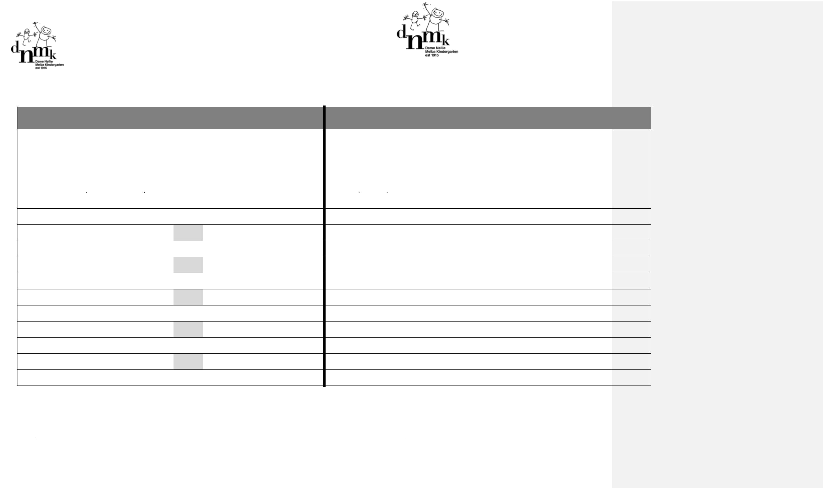

Medication Record

Childs name: ......................................................................................................... Date of birth: ...................................................................................................

To be completed by the parent/guardian

of medication |  | Lastadministered |  |  |  |  |  | When/circumstances | be |  | administered
Name |  |  |  |  |  |  |  |  | to
Name |  | Time |  |  | Date |  |  | Time |  |  |  |  | Date

Dosage to beadministered |  | Method ofadministration | Signature ofparent/Guardian

To be completed by the educator when administered

 | Medicationadministered |  | DosageAdministration | Methodofadministration | Nameofeducatoradministering | Signatureofeducatoradministering | Nameofwitness | Signatureofwitness
 | Time | Date

DNMK Policies & Procedures Administration of Medication Policy

Page 9 of 9

